Title of Your Presentation

Presenting AUTHOR¹, Second AUTHOR², Third AUTHOR^{1∗}

¹Department of Materials Science and Engineering, Institution, Country
²Department of Nanoscience, Institution, Country
*Corresponding author: aaa@abc.edu

Keywords: Kjmst, Japan, Korea (up to 5 Key words)

ABSTRACT

This is an instruction/template for preparing the abstract. Please submit abstracts by using Microsoft word files (ex.: KIM-TK.doc or KIM-TK.docx). If you want to submit more than one abstract, please submit abstract separately with numbered file name (ex.: KIM-TK2.doc or KIM-TK2.docx)[1].
Title, authors, and affiliations; Title must be bolded and centered (Times New Roman, 14 points). The presenting author’s name must be underlined. Family name should be typed in CAPITAL letters, and state all author(s) name(s) and affiliations including department, institution, city, state/province and country (Times New Roman, 12 points). If the affiliations of the other authors are different from the first author, designate affiliations of all authors. The corresponding author should be denoted by a superscripted asterisk (*). Keywords should be less than 5 words. All papers must be written in English.
Contents; Margins are chosen as 2.5cm (1”) for top, bottom, right and left. All information including figures and/or tables must fit on 1 page in A4 paper. Text should be typed single-spaced (Times New Roman, 11 points). File name of the abstract should be typed as “AUTHOR’S LASTNAME-Initials” (ex.: KIM-TK.doc). The abstract should be more than 200 words, but must not exceed 500 words. If you want to insert the Figures, they can be included as shown in Fig. 1.
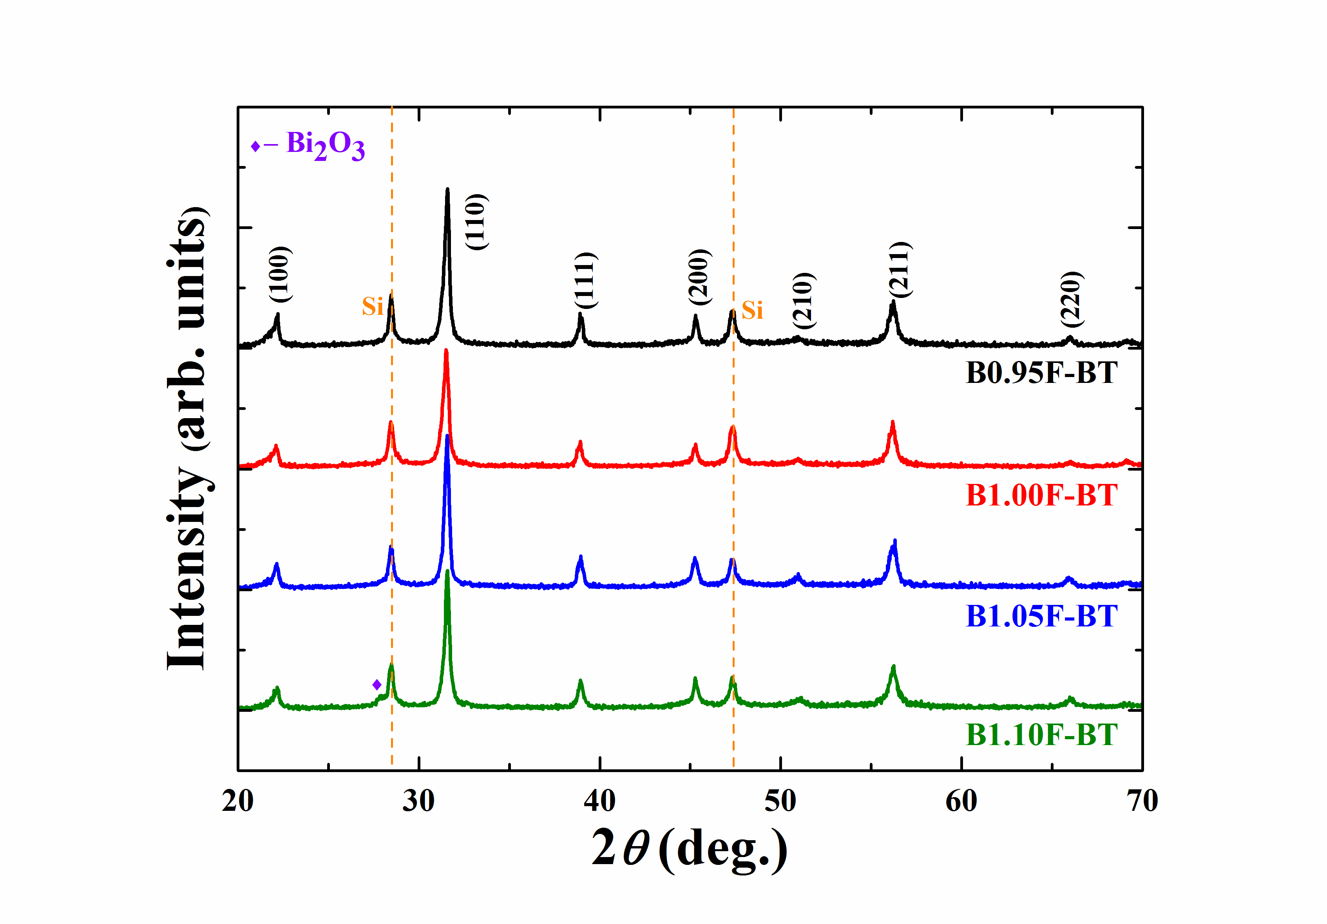
Fig. 1. Included figure example with caption.(11 pt.)

REFERENCES
[1] A. Kim, B. Lee, “Paper Title,” J. Am Ceram. Soc., 124 [5] (2019) 339-43.
[2]

ACKNOWLEDGEMENT (Optional, if necessary)

